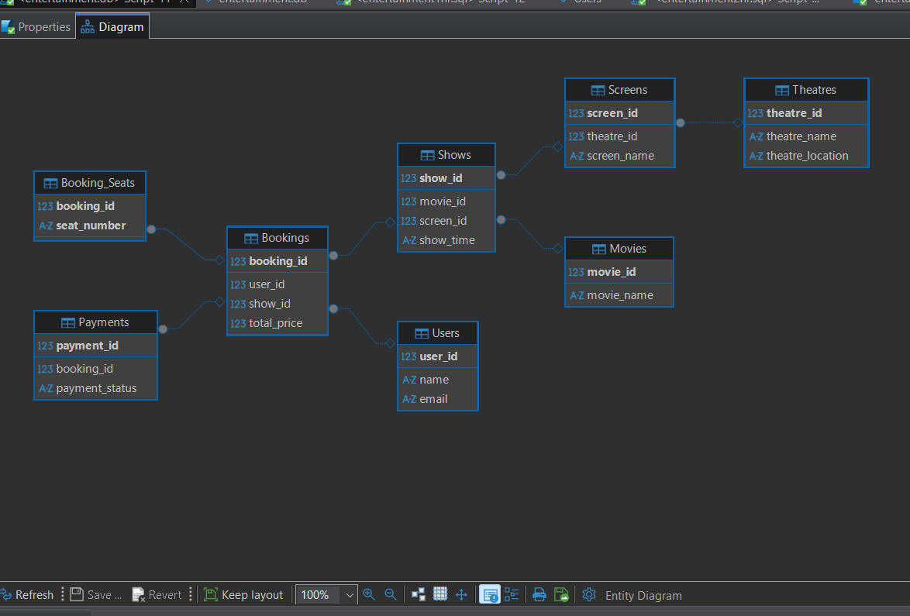
SECTION A: ER diagram After Normalising to 3NF
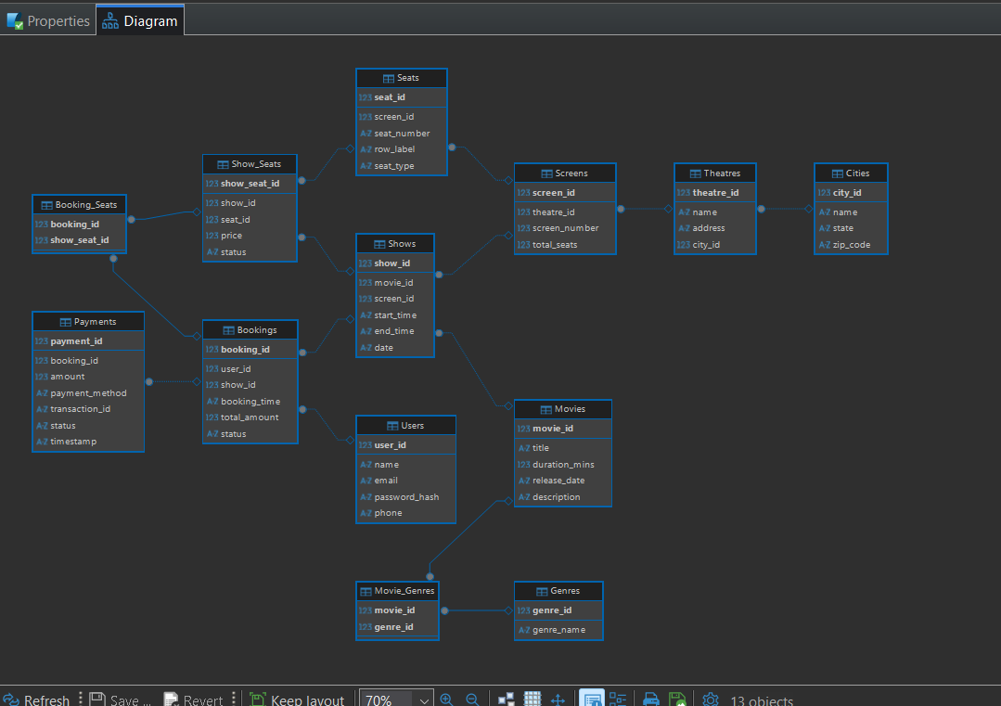
SECTION B : B2 ER DIAGRAM JUST BEFORE UPDATE AFTER NORMALISATION

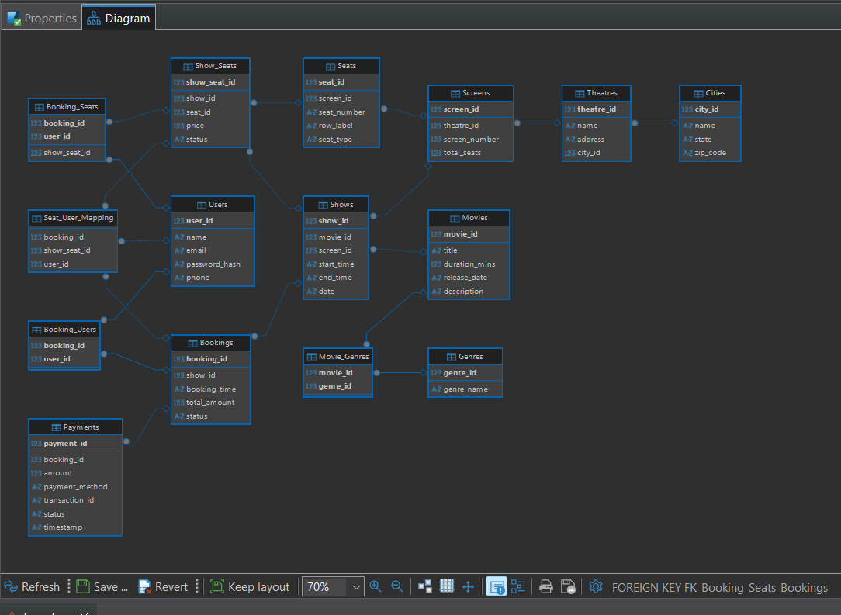

SECTION 2 : ER DIAGRAM AFTER UPDATES OF REQUIREMENTS

